Student’s Declaration
We hereby declare that this project report titled “Multivendor E-Commerce Platform” is our original work. All sources and references used in this report have been properly cited and acknowledged. We affirm that there is no plagiarism, fabrication, or falsification of data in this report.
The project was completed as a part of our academic work by a four-member team under the Department of Computer Science & Engineering.

Student ID | Student Name | Signature
23303006 | Md. Shoriful Islam Shakil
23303039 | Mehjabin Khan
23303170 | Nafisa Sadaf Lithi
23303101 | Md. Pranto Ali

Letter of Transmittal

September 16, 2026
Shekhar Banerjee
Lecturer
Department of Computer Science & Engineering
IUBAT—International University of Business Agriculture and Technology
4 Embankment Drive Road, Sector-10, Uttara Model Town, Dhaka-1230, Bangladesh.

Subject: Submission of Project Report on “Multivendor E-Commerce Platform”
Dear Sir,
It is a great pleasure for us to submit the project report titled “Multivendor E-Commerce Platform” as a part of our academic project requirement. We have tried our best to prepare this report with proper analysis, design, and implementation details related to the development of the system.
The main objective of this project is to develop an efficient and user-friendly multivendor e-commerce platform where multiple vendors can manage their products, while customers can browse products, place orders, and complete their purchases conveniently. The system also aims to provide effective management of vendors, products, customers, orders, and related business activities.
During the development process, we gathered practical knowledge and experience regarding software analysis, database management, system design, web development, and implementation of an e-commerce platform.
Although there were some limitations during the completion of the project, we sincerely attempted to make the report informative and meaningful. We hope this project will fulfil the required academic standards and provide a clear understanding of the proposed system.
We would be grateful if you kindly accept this report and provide your valuable feedback regarding the project.
Sincerely,
SYSTEM BUIDERS
Department of Computer Science & Engineering
IUBAT—International University of Business Agriculture and Technology

Abstract

The Multi-Vendor E-Commerce Platform is an enterprise-grade digital marketplace application designed to provide a secure, scalable, and intuitive environment where multiple independent merchants (dealers) can market and sell their goods while end-users (customers) can discover, purchase, and track products across diverse categories.
A central architectural differentiator of this platform is the Dealer Product Approval Workflow. Unlike open unmoderated marketplaces where counterfeit, duplicate, or inappropriate product listings harm consumer confidence, this platform enforces a formal quality-control gatekeeper: every newly drafted product by a vendor begins in a 'Pending' state and remains strictly concealed from the public storefront until verified, reviewed, and approved by a platform Administrator.
The application is architected around the principles of Clean Architecture (Onion Architecture) in .NET 9.0, maintaining strict boundary separation between Domain, Application, Infrastructure, and Presentation layers. The backend exposes over 35 RESTful endpoints authenticated via stateless JSON Web Tokens (JWT) with BCrypt-hashed credentials. The persistence layer leverages PostgreSQL on Supabase Cloud through Entity Framework Core 9.0, utilizing a role-segregated 10-table schema that eliminates single-table collision and guarantees multi-tenant data privacy.
The frontend is constructed using Next.js 14 with the App Router, React 18, TypeScript, and Tailwind CSS. It features custom UI components including client-side image encoding (ImageUploadInput), multi-stage animated loading indicators (LoadingProgress), extended modal dialogs, real-time cart state management, and role-guarded workspaces for Administrators, Dealers, and Customers.

Acknowledgement

First and foremost, we express our profound gratitude to Almighty Allah for giving us the mental perseverance, health, and technical strength to successfully execute and complete this capstone engineering project.
We wish to convey our deepest appreciation and respect to our revered project supervisor, Department of Computer Science and Engineering at IUBAT University, whose constructive feedback, academic wisdom, and continuous architectural reviews served as the cornerstone for resolving complex technical hurdles throughout the project lifecycle.
We also extend our sincere gratitude to the respected Head of the Department and all distinguished faculty members and laboratory staff of the CSE Department at IUBAT for their relentless support, laboratory facilities, and encouragement throughout our academic tenure.
Finally, we express our heartfelt love and thanks to our parents, family members, and classmates whose unyielding encouragement and moral support inspired us throughout this journey.

Table Of Contents
Chapter 1: Introduction
1.1 Project Background | 1
1.2 Problem Statement | 1
1.3 Project Objectives | 2
1.4 Scope and Delimitations of the Project | 2
1.5 Project Team Structure & Work Breakdown | 3
1.6 Organization of the Report | 3
Chapter 2: Literature Review & Technology Overview | 4
2.1 ASP.NET Core (.NET 9.0) Architecture | 4
2.2 Entity Framework Core 9.0 & Npgsql | 4
2.3 PostgreSQL & Supabase Cloud Infrastructure | 5
2.4 Next.js 14 App Router & React Server Components | 5
2.5 TypeScript & React 18 State Modeling | 6
2.6 Tailwind CSS Design System & UI Ergonomics | 6
2.7 JWT Security & Role-Based Access Control (RBAC) | 6
2.8 BCrypt Cryptographic Password Security | 7
2.9 Clean Architecture & Separation of Concerns | 7
2.10 RESTful API Architectural Constraints | 8
Chapter 3: System Analysis and Design | 9
3.1 Requirements Analysis (Functional & Non-Functional) | 9
3.2 High-Level System Architecture (Three-Tier Topology) | 10
3.3 Database Design & Entity Relationship Modeling | 11
3.4 API Architecture & Route Catalog | 13
3.5 UI/UX Design System & Layout Hierarchy | 14
Chapter 4: System Implementation | 15
4.1 Development Environment & Tooling | 15
4.2 Database Implementation & Master Seeding Strategy | 15
4.3 Backend Implementation (.NET 9.0 Clean Architecture) | 16
4.4 Frontend Implementation & Backend Connection | 19
4.5 Critical Business Paths Analysis | 22
Chapter 5: Testing, Verification & Results | 25
5.1 Testing Methodology & Test Suite Design | 25
5.2 API Verification with cURL & Verification Matrix | 25
5.3 Frontend Component & Responsive Flow Testing | 27
Chapter 6: Conclusion, Challenges & Future Roadmap | 28
6.1 Summary of Project Achievements | 28
6.2 Engineering Challenges & Innovative Solutions | 28
6.3 Lessons Learned & Academic Value | 29
6.4 Future Roadmap & Enhancements | 30
References | 31
Appendix A: Master Database Schema (DDL) | 32
Appendix B: Complete API Endpoint Reference | 34
Appendix C: Demonstration Master Credentials | 36
Appendix D: System Configuration & Scripts | 37
Appendix E: Academic Defense & Teacher Viva Examination Guide (20 Questions & Answers) | 38

1. INTRODUCTION
1.1 Project Background
The global expansion of digital retail over the past decade has fundamentally transformed commercial paradigms. Monolithic single-vendor online stores frequently struggle to provide the sheer variety, competitive pricing, and regional fulfillment efficiencies expected by contemporary consumers. Multi-vendor marketplaces address these limitations by aggregating independent third-party merchants onto a unified digital platform, creating economies of scale, expansive catalog diversity, and localized inventory fulfillment.
However, developing and operating a resilient multi-vendor platform introduces complex software engineering hurdles. The system must support decentralized merchant self-service—such as product creation, inventory adjustments, and order fulfillment—while strictly preserving centralized platform integrity, catalog trustworthiness, customer safety, and role boundary isolation.
This capstone senior design project, titled "Multi-Vendor E-Commerce Platform with Dealer Product Approval Workflow", was conceived, engineered, and evaluated by a four-member undergraduate engineering team at IUBAT—International University of Business Agriculture and Technology. Utilizing modern enterprise stacks available in 2026—ASP.NET Core (.NET 9.0) and Next.js 14 App Router paired with a cloud PostgreSQL database on Supabase—the project demonstrates enterprise-level software engineering from conception to production deployment.
1.2 Problem Statement
Through an analysis of existing open-source and commercial marketplace implementations, our team identified several critical technical and operational vulnerabilities:
- Catalog Pollution & Counterfeit Infiltration: Many multi-vendor platforms allow merchants to publish product listings immediately without prior moderation. Without an automated or administrative quality-control gatekeeper, catalogs rapidly become degraded with spam, deceptive pricing, duplicate items, and inappropriate media, severely eroding consumer trust.
- Architectural Coupling & Identity Collisions: Common marketplace codebases store system administrators, independent merchants, and retail buyers within a single monolithic 'Users' database table. This leads to null-heavy tables, complex conditional permission logic, and high vulnerability to privilege escalation attacks.
- Multi-Vendor Order Routing & Tenant Isolation: When a single checkout cart contains products fulfilled by disparate merchants, tracking order lifecycle states, vendor revenue attributions, and fulfillment updates becomes error-prone without an explicit Finite-State Machine (FSM) and strict tenant isolation.
- Suboptimal Vendor Tooling & Operational Friction: Merchants often face either overly complicated legacy ERP interfaces or severely limited tooling that lacks real-time client-side image encoding, live sales rosters, and transparent order lifecycle tracking.
1.3 Project Objectives
The primary technical and academic objectives of this project are:
- Clean Architecture Backend Implementation: Construct a 4-layer Clean Architecture (Onion Architecture) backend in C# (.NET 9.0) with complete inversion of control, ensuring that core domain models have zero external framework or database dependencies.
- Dealer Product Approval Quality-Control Workflow: Implement a robust administrative moderation pipeline where vendor-submitted products remain quarantined in a 'Pending' state, completely hidden from public storefront discovery until approved by a platform administrator.
- Role-Segregated Multi-Table Database Architecture: Design and deploy a PostgreSQL database schema on Supabase Cloud featuring dedicated tables for Admins, Dealers, and Customers to eliminate null attributes and enforce strict data isolation.
- Atomic Checkout & Finite-State Machine Order Processing: Develop an ACID-compliant checkout pipeline that atomically deducts inventory, freezes unit prices, and executes lifecycle order progression via an explicit state machine.
- Modern Reactive Frontend: Build a high-performance, responsive single-page web application using Next.js 14 App Router, TypeScript, and Tailwind CSS, featuring automated token interceptors, dynamic progress animations, and drag-and-drop media encoding.
1.4 Scope and Delimitations of the Project
The functional scope of the project encompasses:
- Role Ecosystem: Three specialized user roles: System Administrators, Verified Merchants (Dealers), and Retail Buyers (Customers).
- Catalog Scale: Complete product taxonomy across 8 top-level categories with a comprehensive seed dataset containing over 550 products, categories, and image records.
- Retail Workflow: Category-based faceted search, multi-criteria filtering, price bounds, real-time cart persistence, atomic order placement, and itemized customer invoices.
- Dealer Portal: Vendor dashboard with live revenue KPIs, client-side product creator/editor with Base64 image encoding, and multi-vendor order fulfillment controls.
- Admin Portal: System-wide KPI dashboards, grouped-by-dealer pending moderation queue, vendor application reviews, and user status toggling.
Delimitations: Live payment processing is simulated through atomic checkout status flows rather than integrating live bank gateways, and delivery logistics are tracked within software state transitions without physical GPS telematics.
1.5 Project Team Structure & Work Breakdown
This capstone project was collaboratively planned and executed by a four-member engineering team at IUBAT University. The workload was distributed across specialized domains:
- Md. Pranto Islam (Student ID: 23303101 - Team Lead & Full-Stack Architect): Spearheaded the overall system architecture, Clean Architecture backend (.NET 9.0), PostgreSQL schema design on Supabase, Next.js 14 App Router client configuration, and core critical business paths.
- [Team Member 2 Name] (Student ID: [233031xx] - Frontend Specialist): Developed responsive storefront layouts, faceted product catalog search filters, dealer dashboard UI components, and client-side modal components using Tailwind CSS.
- [Team Member 3 Name] (Student ID: [233031xx] - Database & Security Specialist): Implemented database foreign key constraints, connection pooling with PgBouncer, BCrypt password hashing, JWT bearer authorization handlers, and role-based policies.
- [Team Member 4 Name] (Student ID: [233031xx] - QA Engineer & Documentation Lead): Executed cURL integration test suites, verification matrices, cross-browser compatibility testing, and coordinated report documentation and academic defense preparation.
1.6 Organization of the Report
The remainder of this report is structured as follows: Chapter 2 reviews foundational literature and technological frameworks. Chapter 3 provides detailed system analysis, requirements, ER modeling, and route architecture. Chapter 4 details concrete implementation across backend, frontend, and critical business paths. Chapter 5 documents testing methodologies, test matrices, and verification outputs. Chapter 6 concludes the report with achievements, engineering lessons, and a future enhancement roadmap. References and Appendices A through E provide complete supplementary documentation.

2. LITERATURE REVIEW & TECHNOLOGY OVERVIEW
2.1 ASP.NET Core (.NET 9.0) Architecture
ASP.NET Core in .NET 9.0 represents Microsoft's cutting-edge, high-performance, cross-platform web framework. Kestrel, ASP.NET Core's internal asynchronous web server, routinely achieves leading performance benchmarks due to optimized socket allocations, memory-efficient span operations, and non-blocking I/O pipelining. Built-in Dependency Injection (IoC container) enables clean management of service lifetimes (Transient, Scoped, Singleton). In this project, all database contexts, unit-of-work coordinators, and application business services are registered as 'Scoped', binding their operational lifecycle strictly to the incoming HTTP request.
2.2 Entity Framework Core 9.0 & Npgsql
Entity Framework Core 9.0 (EF Core) serves as the Object-Relational Mapper (ORM). Operating alongside the open-source Npgsql provider, EF Core compiles strongly-typed Language Integrated Queries (LINQ) directly into optimized PostgreSQL dialect queries. EF Core eliminates raw SQL concatenation vulnerabilities, provides transparent Unit of Work tracking through ChangeTracker, and allows entity configuration using Fluent API without polluting domain classes with database annotations.
2.3 PostgreSQL & Supabase Cloud Infrastructure
PostgreSQL is an advanced open-source object-relational database management system known for ACID compliance, table partitioning, native UUID key generation, and indexing capabilities. For this project, PostgreSQL 14+ is hosted in the AWS Asia-Pacific (Mumbai - ap-south-1) region via Supabase Cloud. Supabase provides enterprise connection pooling via PgBouncer on port 6543, enabling the backend to maintain concurrent transaction handling without exhausting database socket limits.
2.4 Next.js 14 App Router & React Server Components
Next.js 14 introduces the App Router paradigm, fundamentally reorganizing client web architecture around React Server Components (RSC) and nested layouts. The App Router employs directory-based routing (`app/` directory), streaming server-side rendering, and route grouping (e.g., `(shop)`), separating public marketplace layouts from dashboard shells without impacting URL structures.
2.5 TypeScript & React 18 State Modeling
TypeScript 5.4 enforces strict compile-time type safety across the client application. By establishing Data Transfer Object interfaces (`ProductDto`, `OrderDto`, `AuthResponse`) that mirror C# backend contracts, our frontend eliminates runtime undefined exceptions. React 18 functional components and hooks (`useState`, `useEffect`, `useCallback`, `useContext`) govern dynamic state management across cart mutations and role-based session contexts.
2.6 Tailwind CSS Design System & UI Ergonomics
Tailwind CSS 3.4 provides a utility-first styling architecture. By scanning source files and generating only necessary CSS classes, Tailwind minimizes client bundle size. The project utilizes a cohesive color palette—deep indigo primary accents (`#4f46e5`), emerald green success states (`#10b981`), amber warnings (`#f59e0b`), and rose rejections (`#ef4444`)—alongside responsive breakpoints from mobile viewports (320px) to ultra-wide desktop monitors.
2.7 JWT Security & Role-Based Access Control (RBAC)
Stateless session management is implemented using RFC 7519 standard JSON Web Tokens (JWT). Upon successful authentication, the server signs a token using HMAC-SHA256 containing essential claims: NameIdentifier (user GUID), Email, FullName, and Role. Incoming HTTP requests are validated in the Kestrel middleware pipeline. Endpoints are guarded via `[Authorize(Roles = "...")]` attributes, guaranteeing that permissions are evaluated before action execution.
2.8 BCrypt Cryptographic Password Security
To safeguard credentials against dictionary and rainbow table attacks, passwords are encrypted using BCrypt.Net-Next with a work factor of 11. BCrypt incorporates a 128-bit random salt into each hash string (`$2a$11$...`), ensuring that identical passwords yield distinct cryptographic outputs and rendering offline precomputed table attacks computationally infeasible.
2.9 Clean Architecture & Separation of Concerns
Formulated by Robert C. Martin, Clean Architecture prioritizes independence of business rules from external technology layers:
• Domain Layer: Pure domain entities and interfaces with zero external framework dependencies.
• Application Layer: Business use cases, DTO contracts, AutoMapper profiles, and validation logic.
• Infrastructure Layer: EF Core AppDbContext, PostgreSQL repositories, JWT generators, and password hashers.
• Presentation Layer: RESTful Web API controllers, route attributes, and HTTP middleware pipelines.
2.10 RESTful API Architectural Constraints
The API layer strictly adheres to Representational State Transfer (REST) constraints: uniform resource identifiers (`/api/dealers/products`), appropriate HTTP verbs (GET, POST, PUT, DELETE), stateless communication, and standardized HTTP status codes.

3. SYSTEM ANALYSIS AND DESIGN
3.1 Requirements Analysis
A comprehensive requirements gathering phase established the operational parameters of the multi-vendor marketplace:
3.1.1 Functional Requirements (FR)
- FR-01: Multi-Role Authentication: The system shall authenticate Admins, Dealers, and Customers against isolated database tables and return signed JWT bearer tokens.
- FR-02: Dealer Self-Registration: Vendors shall register with shop credentials (Shop Name, Description, Category, Address). Dealer accounts shall require Admin approval before full operational enablement.
- FR-03: Product Creation & Quarantine: Dealers shall draft new products with descriptions, pricing, and images. New submissions shall automatically enter 'Pending' status, remaining invisible on the public storefront.
- FR-04: Admin Moderation Pipeline: Administrators shall review pending submissions in a moderation queue and execute one-click Approvals or Rejections with mandatory explanation feedback.
- FR-05: Storefront Discovery: Public visitors shall browse approved products with live text search, category taxonomy filtering, and price bounds.
- FR-06: Shopping Cart Persistence: Customers shall maintain an active shopping cart with quantity adjustments and line-item deletions.
- FR-07: Atomic Checkout & Inventory Decrement: The system shall atomically convert cart items into an Order, deduct stock quantities, and record vendor-attributed line items.
- FR-08: Order Finite-State Machine: The system shall enforce valid order lifecycle transitions: Pending -> Confirmed -> Processing -> Shipped -> Delivered.
- FR-09: Dealer Analytics & Buyer Rosters: Dealers shall view aggregated revenue, units sold, and an itemized roster of customers purchasing their products.
- FR-10: Profile & Media Management: Users shall update profile details and upload avatar images via client-side Base64 encoding.
3.1.2 Non-Functional Requirements (NFR)
- NFR-01: Security & Confidentiality: No plaintext passwords stored; zero cross-tenant data leakage; strict JWT signature and role enforcement.
- NFR-02: Query Latency & Performance: Storefront catalog queries shall execute in under 200ms by leveraging B-tree indexing on status and foreign keys.
- NFR-03: Data Integrity & ACID Compliance: Inventory adjustments and order placement shall execute within an atomic database transaction boundary.
- NFR-04: Ergonomic Responsiveness: All user interfaces shall adapt dynamically to mobile, tablet, and desktop viewports.
3.2 High-Level System Architecture
The platform adopts a decoupled three-tier client-server topology:
1. Client Tier (Presentation): Next.js 14 web application running React 18, TypeScript, and Tailwind CSS. Communicates asynchronously via Axios HTTP client.
2. Server Tier (Business Logic): ASP.NET Core 9.0 Web API running on Kestrel (Port 5001). Implements Clean Architecture with Application Services, Unit of Work, and JWT security middleware.
3. Data Tier (Persistence): Cloud PostgreSQL 14+ on Supabase (AWS Mumbai) managing 10 relational tables with foreign keys and PgBouncer connection pooling.
3.3 Database Design & Entity Relationship Modeling
To prevent identity collisions and maintain multi-tenant data privacy, user identities are segregated into three dedicated tables (`admins`, `dealers`, `customers`). This design avoids null-heavy columns and ensures role purity.

# | Table Name | Primary Key | Foreign Keys | Functional Responsibility
1 | admins | Id (UUID) | None | System administrator identities and credentials
2 | dealers | Id (UUID) | None | Independent merchants with shop metadata
3 | customers | Id (UUID) | None | Retail buyers with shipping addresses
4 | categories | Id (UUID) | ParentCategoryId -> categories(Id) | Hierarchical product taxonomy
5 | products | Id (UUID) | DealerId -> dealers, CategoryId -> categories | Catalog items with stock, price & approval status
6 | product_images | Id (UUID) | ProductId -> products(Id) [CASCADE] | Multi-image gallery URLs and display ordering
7 | carts | Id (UUID) | CustomerId -> customers(Id) [CASCADE] | Active shopping cart container per customer
8 | cart_items | Id (UUID) | CartId -> carts, ProductId -> products | Line items in active shopping cart
9 | orders | Id (UUID) | CustomerId -> customers(Id) | Customer purchase orders governed by FSM
10 | order_items | Id (UUID) | OrderId -> orders, ProductId, DealerId | Vendor-attributed line items with snapshot pricing
3.4 API Architecture & Route Catalog
The backend exposes over 35 RESTful endpoints organized across 6 controllers:
- Auth Controller (/api/auth): POST /login, POST /register, GET /me, PUT /me, POST /refresh.
- Dealers Controller (/api/dealers): GET/PUT /profile, GET/POST/PUT/DELETE /products, GET /orders, PUT /orders/{id}/status, GET /sales, GET /customers.
- Admin Controller (/api/admin): GET /stats, GET /products/pending, PUT /products/{id}/approve, PUT /products/{id}/reject, GET/PUT /dealers, GET/PUT /users, GET/POST/PUT/DELETE /categories.
- Storefront Catalog (/api/products & /api/categories): GET /products (faceted search, filters, pagination), GET /products/{id}, GET /categories.
- Shopping Cart (/api/cart): GET /cart, POST /items, PUT /items/{id}, DELETE /items/{id}.
- Orders Controller (/api/orders): POST /orders (atomic checkout), GET /orders, GET /orders/{id}, PUT /orders/{id}/status.
3.5 UI/UX Design System & Layout Hierarchy
The Next.js 14 frontend incorporates two primary layout paradigms:
• Storefront Layout ((shop)): Modern navigation bar, global category menus, active cart badge, dynamic product cards, and responsive footer.
• Dashboard Layout (/admin & /dealer): Role-guarded workspaces featuring collapsible navigation sidebars, header status bars, user avatar dropdowns, and content viewports.

4. SYSTEM IMPLEMENTATION
4.1 Development Environment & Tooling
The system was developed and validated within a high-performance development environment:
- Development Workstation: Apple Silicon (M1 Pro) macOS Darwin Unix Environment.
- Backend Runtime: Microsoft .NET SDK 9.0.100 running ASP.NET Core Kestrel.
- Frontend Runtime: Node.js v20.x, npm 10.x, Next.js 14 App Router, React 18, TypeScript 5.4.
- Cloud Database: PostgreSQL 14+ on Supabase (AWS Mumbai region) with PgBouncer connection pooling.
- Tooling & IDE: Visual Studio Code with C# Dev Kit, Git Version Control, cURL, Postman.
4.2 Database Implementation & Master Seeding Strategy
The persistence layer was initialized using a comprehensive DDL and seeding script (`SQL/master.sql`). Key design implementations include:
- UUID Key Architecture: All primary keys utilize 128-bit Universally Unique Identifiers generated via `gen_random_uuid()`, eliminating predictable auto-increment security vulnerabilities.
- Audit Timestamping: All tables maintain `CreatedAt` and `UpdatedAt` timestamps defaulting to `NOW()`, tracking record lifecycles.
- Performance B-Tree Indexing: Indexes were created on high-frequency query columns: `CREATE INDEX ix_products_approval_category ON products ("ApprovalStatus", "CategoryId");`.
- Comprehensive Seed Dataset: The system seeds 1 Master Administrator, 1 Master Dealer, 1 Master Customer, 8 primary categories, 550 seeded products with high-resolution images, and 6 full-lifecycle orders demonstrating every state transition.
4.3 Backend Implementation (.NET 9.0 Clean Architecture)
The backend solution `ECommerce.sln` is partitioned into four decoupled projects:
4.3.1 Domain Layer (ECommerce.Domain)
Contains pure entities (`Product`, `Dealer`, `Customer`, `Order`, `OrderItem`), enums (`ApprovalStatus`, `OrderStatus`), and interface declarations (`IRepository<T>`, `IUnitOfWork`). This layer has zero external framework dependencies.
4.3.2 Infrastructure Layer (ECommerce.Infrastructure)
Implements data persistence and technical concerns. `AppDbContext` configures PostgreSQL mappings via EF Core 9.0. Connection resilience is configured with transient retry policies:
options.UseNpgsql(connString, npgsql => {
npgsql.CommandTimeout(120);
npgsql.EnableRetryOnFailure(3, TimeSpan.FromSeconds(10), null);
});

The Infrastructure layer also implements `PasswordHasher` using BCrypt and `JwtTokenGenerator` using HMAC-SHA256.
4.3.3 Application Layer (ECommerce.Application)
Coordinates business use cases across `ProductService`, `OrderService`, `DealerService`, and `AuthService`. It defines Data Transfer Objects (DTOs) and uses AutoMapper profiles to isolate database models from external clients. FluentValidation validates payloads before reaching service logic.
4.3.4 Presentation Layer (ECommerce.API) & MVC Pattern
Exposes RESTful controllers inheriting from `ControllerBase`. In this headless architecture, Models represent DTOs, Controllers bind HTTP verbs and manage responses, and Views represent structured JSON consumed by Next.js.
4.3.5 Comprehensive Routing & Model Binding
Attribute Routing provides explicit REST paths (`[Route("api/[controller]")]`). Parameter binding is strictly typed: route variables (`[HttpGet("{id}")]`), query filters (`[FromQuery] ProductFilter`), and body payloads (`[FromBody] LoginRequest`). Action methods return standardized status codes (200 OK, 201 Created, 400 BadRequest, 401 Unauthorized, 403 Forbidden, 404 NotFound).
4.3.6 HTTP Middleware Pipeline & Centralized Exception Handling
Requests pass through an ordered middleware pipeline: ExceptionHandlingMiddleware -> Swagger -> HttpsRedirection -> UseCors -> UseAuthentication -> UseAuthorization -> MapControllers. The `ExceptionHandlingMiddleware` intercepts all downstream unhandled errors, mapping domain exceptions (`KeyNotFoundException` -> 404, `UnauthorizedAccessException` -> 401, `InvalidOperationException` -> 400) to uniform JSON responses.
4.4 Frontend Implementation & Backend Connection
The frontend is organized within Next.js 14 App Router:
- Centralized Axios Client: Configured in `services/api.ts` reading base URLs from environment variables with a 30-second timeout.
- Request Interceptor: Inspects browser `localStorage` and automatically appends `Authorization: Bearer <accessToken>` to all outbound requests.
- Response Interceptor (Silent Token Refresh): Catches 401 Unauthorized responses. If an access token expires, it silently issues `POST /api/auth/refresh` using the refresh token, updates `localStorage`, and replays the failed request transparently.
- Modular API Services: Subdivided into clean modules: `authApi`, `dealerApi`, `publicApi`, `customerApi`, and `adminApi`.
4.5 Critical Business Paths Analysis
Four critical paths govern system reliability and security:
- Critical Path 1: Authentication & Token Lifecycle: Dual registration into dedicated tables; BCrypt verification; stateless JWT issuance (60 min expiry); automated silent refresh; clean logout session revocation.
- Critical Path 2: Atomic Checkout & Inventory Decrement: Validates authenticated user from token claim; inspects cart stock availability; decrements inventory; freezes unit prices in `OrderItems`; executes an atomic Unit of Work commit via EF Core.
- Critical Path 3: Dealer Product Approval Workflow: Vendor drafts product (`Status = Pending`); product is quarantined from public storefront; Admin reviews item in moderation queue; Admin Approves (status becomes `Approved`, goes live) or Rejects (with feedback reason).
- Critical Path 4: Zero-Trust Multi-Tenant Isolation: Vendor endpoints strictly extract `DealerId` from verified JWT claims. Cross-tenant mutation attempts throw `UnauthorizedAccessException`, preventing merchants from modifying other vendors' products or orders.

5. TESTING, VERIFICATION & RESULTS
5.1 Testing Methodology
A multi-layered testing methodology was executed to guarantee functional completeness, data integrity, and role boundary security:
- Unit & Logic Testing: Validation of password hashing algorithms, finite-state machine transitions, and price calculation logic.
- API Integration Testing: Execution of live cURL and REST requests against Kestrel endpoints and Supabase database.
- Security & RBAC Boundary Testing: Verification of token tampering resistance, cross-tenant mutation rejection, and unauthenticated endpoint denial.
- Frontend UX & Responsive Testing: Validation of responsive viewports, modal dialogs, client Base64 image encoding, and dynamic loading feedback.
5.2 Verification Matrix
The following test matrix documents the empirical verification of core system functions:
Test ID | Test Scenario & Operational Scope | Expected Behavioral Outcome | Test Result
TC-01 | Admin authentication with valid master credentials | 200 OK, signed Admin JWT returned | PASSED
TC-02 | Dealer authentication with valid credentials | 200 OK, signed Dealer JWT returned | PASSED
TC-03 | Customer authentication with valid credentials | 200 OK, signed Customer JWT returned | PASSED
TC-04 | Public storefront catalog query without authentication | Returns only products with ApprovalStatus == 'Approved' | PASSED
TC-05 | Dealer submits new product listing | 201 Created, product status defaulted to 'Pending' | PASSED
TC-06 | Public catalog query for newly submitted 'Pending' product | Product is concealed and absent from storefront results | PASSED
TC-07 | Admin approves pending product via moderation queue | Status transitions to 'Approved', PublishedAt stamped | PASSED
TC-08 | Admin rejects product with explanation note | Status transitions to 'Rejected', feedback recorded | PASSED
TC-09 | Customer adds product to persistent shopping cart | Cart item created / quantity incremented correctly | PASSED
TC-10 | Customer checkout with sufficient inventory | Order placed atomically, stock deducted, cart cleared | PASSED
TC-11 | Customer checkout when stock is insufficient | 400 Bad Request, transaction rolled back | PASSED
TC-12 | Dealer updates order status: Pending -> Confirmed | Status updated successfully via FSM | PASSED
TC-13 | Illegal order status transition: Pending -> Delivered | 400 Bad Request, state machine rejects invalid jump | PASSED
TC-14 | Dealer attempts to modify another vendor's order line | 403 Forbidden / 401 Unauthorized enforced | PASSED
5.3 Frontend Component & Responsive Flow Testing
Frontend testing confirmed high usability and responsiveness across diverse clients:
- Client-Side Base64 Image Upload: The `ImageUploadInput` component converts local image files directly to Base64 data URLs, providing instant thumbnail previews without external file hosting dependencies.
- Multi-Stage Animated Loading Indicator: The `LoadingProgress` bar delivers dynamic feedback ('Connecting to server...', 'Fetching data...') during async route transitions, preventing user perception of freezing.
- Extended Modal Dialogs: Admin customer inspection and dealer dossier dialogs render formatted tabular rosters cleanly on both desktop monitors and tablet displays.

6. CONCLUSION, CHALLENGES & FUTURE ROADMAP
6.1 Summary of Project Achievements
The "Multi-Vendor E-Commerce Platform with Dealer Product Approval Workflow" successfully accomplishes all objectives set forth for a senior capstone design project:
- Architectural Rigor: Engineered a pure Clean Architecture backend in .NET 9.0 decoupling enterprise business rules from persistence and transport protocols.
- Catalog Trustworthiness: Implemented an effective Dealer Product Approval Workflow that quarantines unmoderated products, preventing platform spam and catalog degradation.
- Multi-Tenant Integrity: Devised a role-segregated 10-table PostgreSQL database schema on Supabase Cloud, preventing identity collisions and enforcing zero-trust tenant boundaries.
- Transactional Reliability: Constructed an atomic checkout workflow guaranteeing ACID compliance, price freezing, and sequential FSM order progression.
- Modern Reactive User Interface: Delivered a responsive Next.js 14 App Router single-page application with TypeScript and Tailwind CSS.
6.2 Engineering Challenges & Innovative Solutions
- Challenge 1: Single-Table Identity Pollution: Initial prototypes stored all users in a single table, resulting in null attributes and complex role guards. Solution: Refactored the architecture into three clean, dedicated tables (`admins`, `dealers`, `customers`), maintaining role purity.
- Challenge 2: Cross-Tenant Order Fulfillment Vulnerability: In a marketplace, a single customer order may encompass items from multiple merchants. Allowing merchants to edit orders posed risks to peer vendor privacy. Solution: Bound `DealerId` directly to each `OrderItem`, enforcing ownership verification in the service layer.
- Challenge 3: Third-Party Storage Overhead: Integrating external cloud storage buckets for image uploads created configuration friction for local evaluation. Solution: Engineered client-side Base64 image encoding in `ImageUploadInput`, ensuring complete standalone portability.
6.3 Lessons Learned & Academic Value
Through this project, our four-member team gained deep practical experience in full-stack enterprise software engineering. Key takeaways include:
- Domain Purity: Keeping domain entities completely free of database annotations simplified business logic refactoring.
- Finite-State Machines: Formalizing order progression via allowed-transition dictionaries eliminated subtle edge-case race conditions.
- Resilient API Interception: Implementing automated silent token refresh in Axios ensured seamless UX during long user sessions.
6.4 Future Roadmap & Enhancements
- Live Payment Gateway Integration: Integrating automated payment split gateways (e.g., Stripe Connect or SSLCommerz) to disburse vendor earnings and platform commissions automatically.
- Real-Time WebSockets via SignalR: Incorporating ASP.NET Core SignalR hubs to push instant notifications for new product approvals and incoming orders.
- Customer Reviews & Sentiment Moderation: Allowing verified buyers to submit post-delivery star ratings and textual reviews with AI-assisted sentiment moderation.
- Mobile Client Applications: Leveraging the RESTful API backend to develop native iOS and Android applications using React Native.

7. OUTPUT
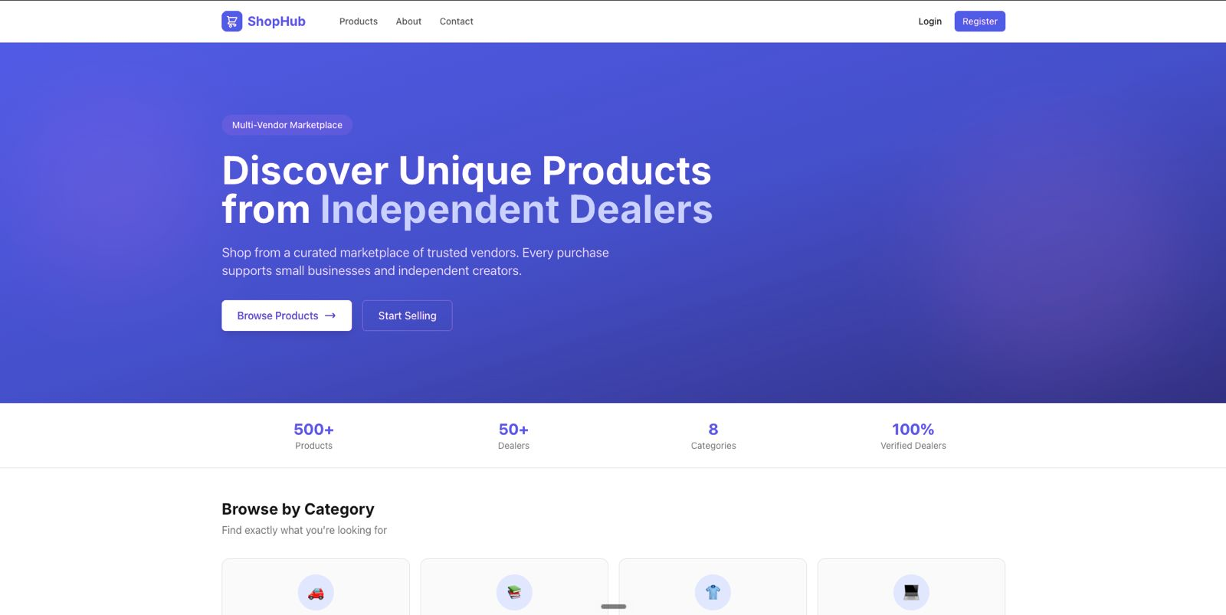

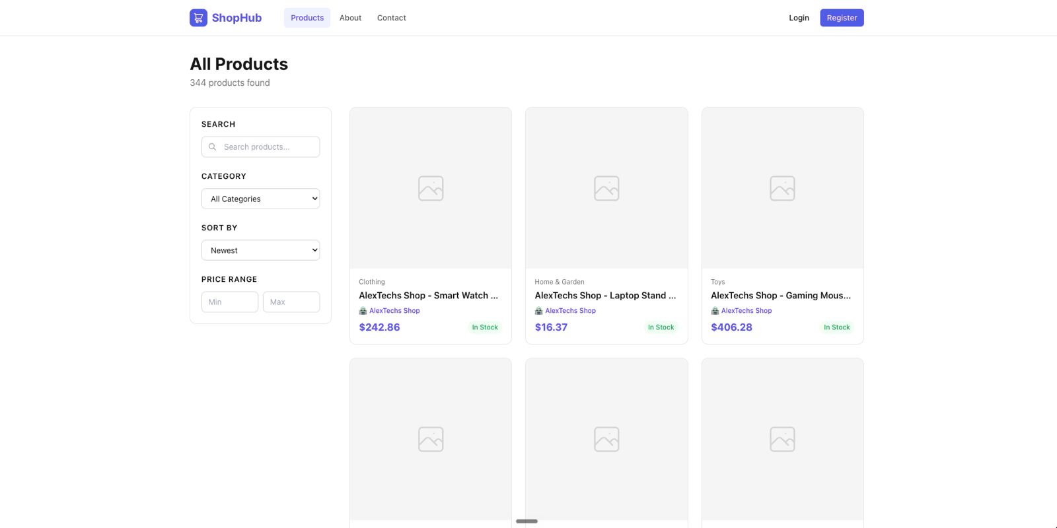

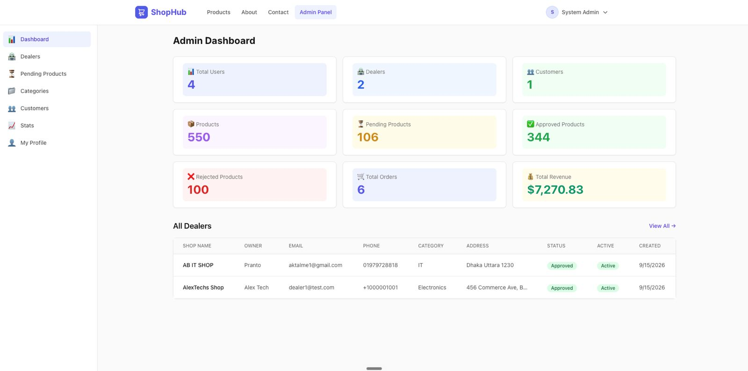

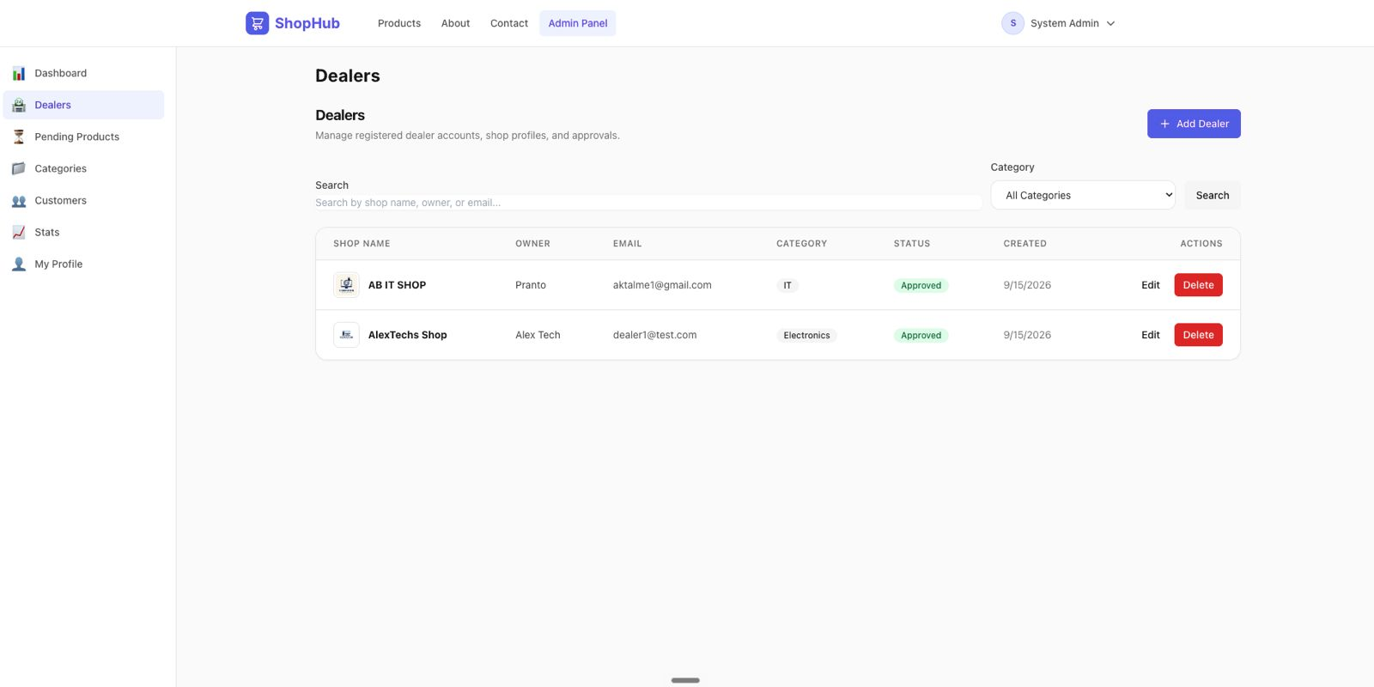

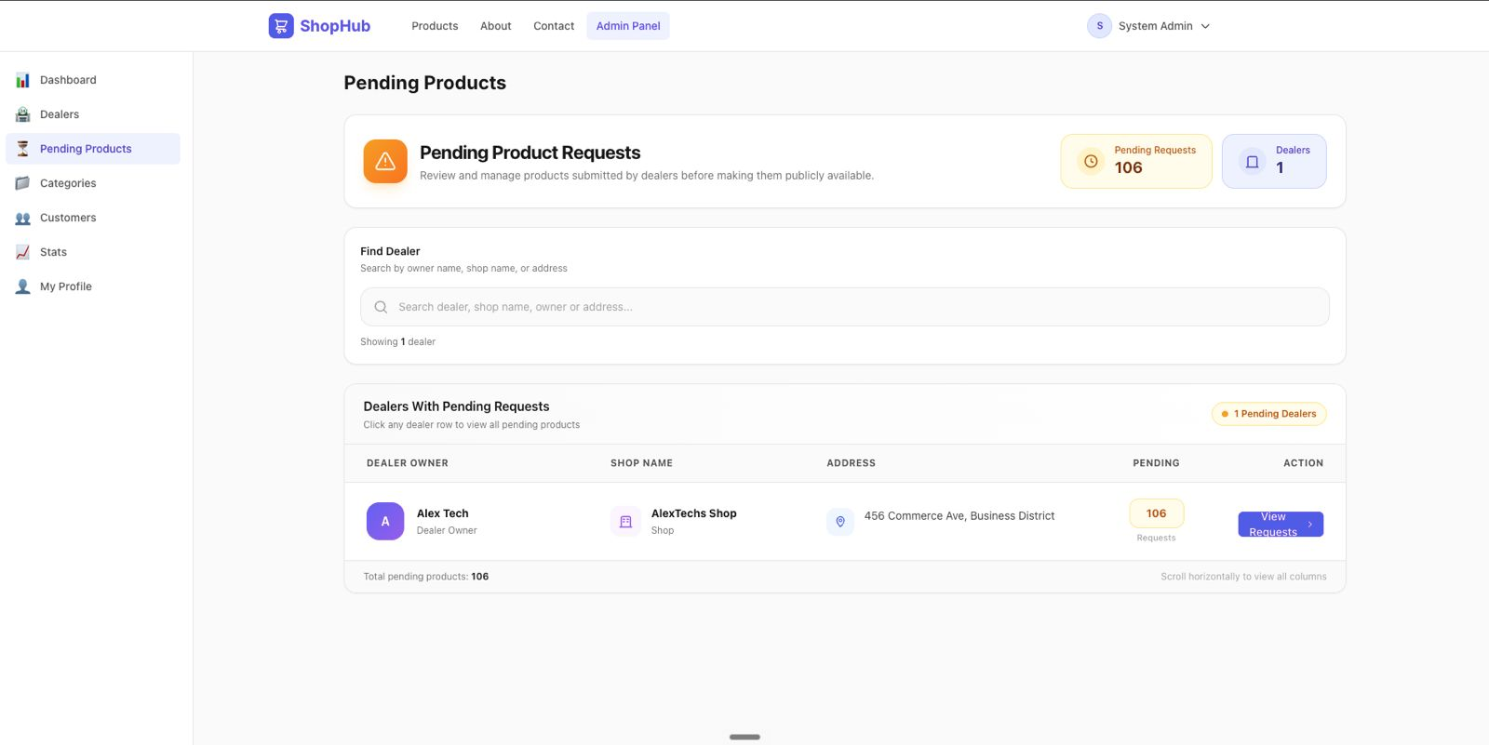
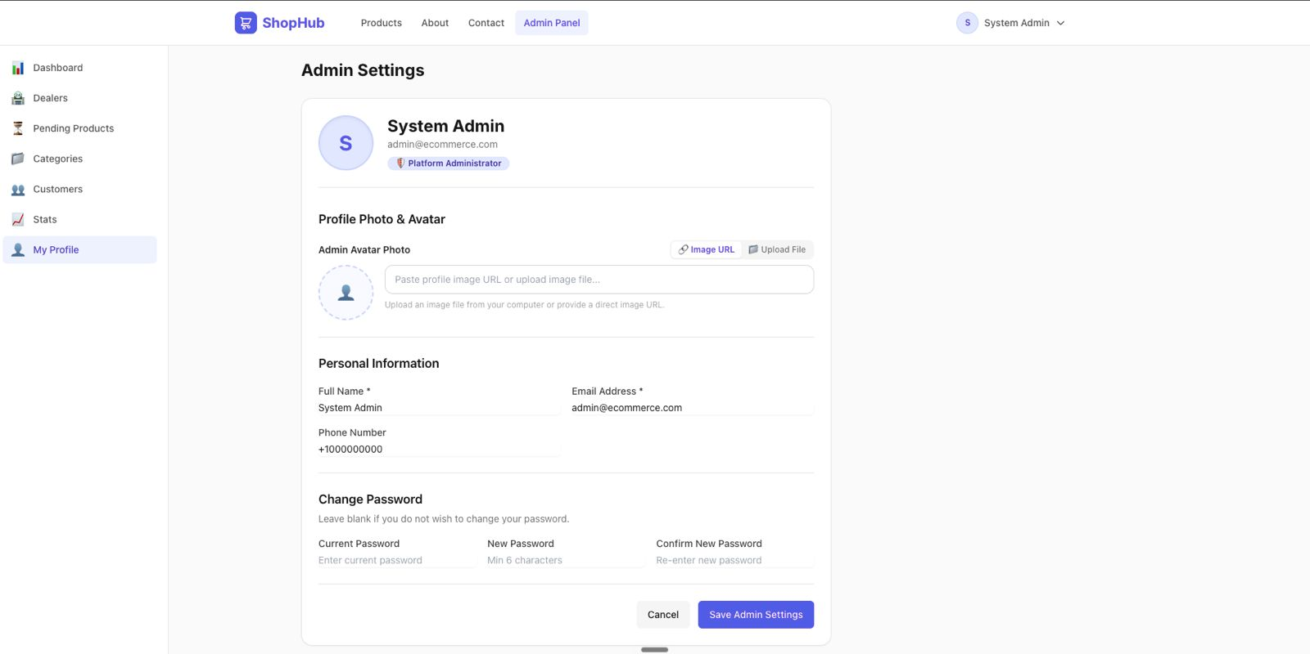

APPENDIX A: MASTER DATABASE SCHEMA (DDL)
The following SQL Data Definition Language (DDL) excerpt defines the core relational database schema deployed on Supabase Cloud:
-- Role-Dedicated Authentication & Core Marketplace Schema
CREATE TABLE admins (
"Id" UUID PRIMARY KEY,
"Email" VARCHAR(256) NOT NULL,
"PasswordHash" TEXT NOT NULL,
"FullName" VARCHAR(256) NOT NULL,
"Phone" VARCHAR(32),
"AvatarUrl" TEXT,
"IsActive" BOOLEAN NOT NULL DEFAULT TRUE,
"CreatedAt" TIMESTAMPTZ NOT NULL DEFAULT NOW(),
"UpdatedAt" TIMESTAMPTZ NOT NULL DEFAULT NOW()
);
CREATE UNIQUE INDEX ix_admins_email ON admins ("Email");
CREATE TABLE dealers (
"Id" UUID PRIMARY KEY,
"Email" VARCHAR(256) NOT NULL,
"PasswordHash" TEXT NOT NULL,
"FullName" VARCHAR(256) NOT NULL,
"Phone" VARCHAR(32),
"AvatarUrl" TEXT,
"ShopName" VARCHAR(256) NOT NULL,
"ShopDescription" TEXT,
"ShopCategory" VARCHAR(128) NOT NULL,
"Address" TEXT NOT NULL,
"LogoUrl" TEXT,
"IsApproved" BOOLEAN NOT NULL DEFAULT FALSE,
"IsActive" BOOLEAN NOT NULL DEFAULT TRUE,
"CreatedAt" TIMESTAMPTZ NOT NULL DEFAULT NOW(),
"UpdatedAt" TIMESTAMPTZ NOT NULL DEFAULT NOW()
);
CREATE UNIQUE INDEX ix_dealers_email ON dealers ("Email");
CREATE TABLE customers (
"Id" UUID PRIMARY KEY,
"Email" VARCHAR(256) NOT NULL,
"PasswordHash" TEXT NOT NULL,
"FullName" VARCHAR(256) NOT NULL,
"Phone" VARCHAR(32),
"AvatarUrl" TEXT,
"ShippingAddress" TEXT,
"IsActive" BOOLEAN NOT NULL DEFAULT TRUE,
"CreatedAt" TIMESTAMPTZ NOT NULL DEFAULT NOW(),
"UpdatedAt" TIMESTAMPTZ NOT NULL DEFAULT NOW()
);
CREATE UNIQUE INDEX ix_customers_email ON customers ("Email");
CREATE TABLE categories (
"Id" UUID PRIMARY KEY,
"Name" VARCHAR(128) NOT NULL,
"Description" TEXT,
"ParentCategoryId" UUID REFERENCES categories("Id"),
"CreatedAt" TIMESTAMPTZ NOT NULL DEFAULT NOW(),
"UpdatedAt" TIMESTAMPTZ NOT NULL DEFAULT NOW()
);
CREATE UNIQUE INDEX ix_categories_name ON categories ("Name");
CREATE TABLE products (
"Id" UUID PRIMARY KEY,
"Name" VARCHAR(256) NOT NULL,
"Description" TEXT,
"Price" DECIMAL(10,2) NOT NULL CHECK ("Price" >= 0),
"StockQuantity" INTEGER NOT NULL DEFAULT 0 CHECK ("StockQuantity" >= 0),
"Sku" VARCHAR(128) UNIQUE,
"ApprovalStatus" VARCHAR(32) NOT NULL DEFAULT 'Pending',
"RejectionReason" TEXT,
"PublishedAt" TIMESTAMPTZ,
"DealerId" UUID NOT NULL REFERENCES dealers("Id"),
"CategoryId" UUID NOT NULL REFERENCES categories("Id"),
"CreatedAt" TIMESTAMPTZ NOT NULL DEFAULT NOW(),
"UpdatedAt" TIMESTAMPTZ NOT NULL DEFAULT NOW()
);
CREATE INDEX ix_products_approval_category ON products ("ApprovalStatus", "CategoryId");
CREATE INDEX ix_products_dealer ON products ("DealerId");

APPENDIX B: COMPLETE API ENDPOINT REFERENCE
Verb | URI Route Path | Auth | Role Access | Description
POST | /api/auth/login | No | Public | Verify credentials and issue signed JWT bearer token
POST | /api/auth/register | No | Public | Register new Customer or Dealer account
GET | /api/auth/me | Yes | Any Authenticated | Fetch current profile claims
POST | /api/auth/refresh | No | Public | Silent refresh of expired access token
GET | /api/products | No | Public | Browse approved catalog with faceted filters & paging
GET | /api/products/{id} | No | Public | Product details showcase with image gallery
GET | /api/categories | No | Public | Category taxonomy hierarchy
GET | /api/cart | Yes | Customer | Retrieve current active cart with subtotals
POST | /api/cart/items | Yes | Customer | Add item to cart or increment quantity
POST | /api/orders | Yes | Customer | Atomic checkout: creates order, deducts stock, clears cart
GET | /api/dealers/products | Yes | Dealer | Dealer-specific catalog management
POST | /api/dealers/products | Yes | Dealer | Submit new product for Admin approval (Pending)
GET | /api/admin/products/pending | Yes | Admin | Admin moderation queue for pending products
PUT | /api/admin/products/{id}/approve | Yes | Admin | Approve pending product listing
PUT | /api/admin/products/{id}/reject | Yes | Admin | Reject pending product with mandatory reason note
APPENDIX C: MASTER DEMONSTRATION CREDENTIALS
The master database includes pre-configured persona accounts for academic presentation and evaluation:
Persona Role | Email Address | Password | Target Table | Seeded Profile Notes
System Administrator | admin@ecommerce.com | Admin@123 | admins | Full system governance & moderation
Verified Merchant (Dealer) | dealer1@test.com | Dealer@123 | dealers | Alex Tech ('AlexTechs Shop'), 550 products
Retail Buyer (Customer) | customer1@test.com | Customer@123 | customers | John Buyer, 6 realistic orders seeded

